NON-DISCLOSURE AGREEMENT

This Non-Disclosure NDA (“NDA”) is made at {{ city }}, {{ state }} on the {{ joining_date }} by and between:

Lighthouse Communities Foundation, a Section 8 company, incorporated under the Companies Act, 2013, and having its registered office at the lighthouse complex, Off Bremen Chowk, Spicer College Road, Aundh, Pune-411014 (hereinafter referred to as "Disclosing Party", which expression shall unless repugnant to the context hereof, mean and include its affiliates, successors and assigns) of the FIRST PART;

AND

{{ emp_name }}, being a citizen of India, currently residing at {{ address }} (hereinafter referred to as the “Receiving Party”, which expression shall, unless repugnant to the context or meaning thereof, be deemed to mean and include {{ his_or_her }} legal heirs, administrators, executors, successors-in-interest and permitted assigns) of the SECOND PART.

For the purpose of this NDA, the Disclosing Party and Receiving Party shall be individually referred to as “Party” and collectively as “Parties”.

- The Parties recognize that certain information including Confidential Information (as defined hereinafter) would be exchanged by the Disclosing Party to the Receiving Party with respect to the Permitted Purpose (as defined hereinafter);
- The Parties wish to enter into this NDA to confirm that the Confidential Information will be treated as confidential in accordance with the terms of this NDA, and to provide the Disclosing Party with certain rights and remedies and to protect the confidentiality of the Confidential Information; and

- The Parties have agreed to enter into this NDA to record their understanding in respect of the disclosure of such information.

      - DEFINITIONS:
1.1 “Confidential Information” means, to the extent previously, presently or subsequently disclosed by the Disclosing Party, the, notes, discussions, trade secrets, all financial, business, legal and technical information of the Disclosing Party or any of its affiliates, suppliers, customers and employees (including information about the, research, development, operations, marketing, transactions, regulatory affairs, discoveries, inventions, methods, processes, articles, contents, google analytics, facebook insights, twitter insights, instagram insights, materials, algorithms, software, specifications, designs, drawings, data, strategies, plans, prospects, know-how and ideas, whether tangible or intangible, client business information and related information regarding partners, and including all copies, abstracts, summaries, analyses and other derivatives thereof), that is marked or otherwise identified as proprietary or confidential at the time of disclosure, or that by its nature would be understood by a reasonable person to be proprietary or confidential, content strategy and launch strategy. Confidential Information shall not include any information that (a) was rightfully known to the Receiving Party without restriction before receipt from the Disclosing Party, (b) is rightfully disclosed to the Receiving Party without restriction by a third party, (c) is or becomes generally known to the public without violation of this NDA by the Receiving Party or (d) is independently developed by the Receiving Party or its employees without access to or reliance on such information.
  - “Authorized Representative” shall mean, as to any Person, its directors, officers, employees, agents, sub-contractors and advisors (including, without limitation, financial advisors, attorneys and accountants);

  - “Person” shall be broadly interpreted to include, without limitation, any corporation, company, partnership, other entity or individual;

  - “Permitted Purpose” shall mean and include the talks/ negotiations between the Parties and/or with third party, during the term of employment, in relation to the services for which the Receiving Party has been recruited by the Disclosing Party and such other ancillary services, in pursuance of which certain items of Confidential Information are being/ shall continue to be disclosed by the Disclosing Party to the Receiving Party;

  - “Affiliate” refers to any company which is, now or during the term of this NDA, controlled by, controlling or under common control with a Party. “Control” means direct management control or direct or indirect ownership of more than fifty (50) percent of the voting and equity interests of the controlled corporation or entity. An entity is considered as an Affiliate only so long as such Control exists, provided that any entity which ceases to be an Affiliate under this NDA shall still have an obligation to maintain the confidentiality obligations hereunder, until the Party is obligated to maintain the said obligation.

NOW THEREFORE IT IS HEREBY AGREED BY AND BETWEEN THE PARTIES AND THIS NDA WITNESSETH AS UNDER:
            - OBLIGATIONS

The Receiving Party shall: (i) only disclose the Confidential Information to such others, as and when permitted by the Disclosing Party, provided such personnel are bound by confidentiality restrictions no less protective than those set forth in this NDA; (ii) not disclose any Confidential Information to any third party without the Disclosing Party’s prior written consent; (iii) use such Confidential Information only to the extent required for the purpose of evaluating a potential business relationship; (iv) not reproduce Confidential Information in any form except as required to accomplish such purpose; (v) not reverse engineer, decompile, or disassemble any software disclosed by the Disclosing Party ; and (vi) promptly provide the Disclosing Party’s with notice of any actual or threatened breach of the terms of this NDA. However, the Receiving Party may disclose confidential Information in accordance with a judicial or other governmental order provided that such Party gives the Disclosing Party prior written notice as far as practically possible.

            - EXCLUSIONS

The foregoing restrictions on disclosure shall not apply to Confidential Information which: (a) is now or hereafter becomes generally known through no act or failure to act on the Receiving Party part; (b) the Receiving Party independently knows at the time of receiving such information, as evidenced by its written records; (c) a third party hereafter furnishes to the Receiving Party without breaching any obligation of confidentiality and without restriction on disclosure; (d) the Receiving Party has independently developed without using the Disclosing Party’s Confidential Information or breaching this NDA, as evidenced by its written records; or (e) the Disclosing Party gives written permission to the Receiving Party to disclose.

            - OWNERSHIP

All Confidential Information (including copies thereof) shall remain the property of the Disclosing Party and shall be returned (or, at the Disclosing Party’s option, destroyed) upon written request or upon the Receiving Party’s need for it has expired, and in any event, upon termination of this NDA. No rights or licenses to trademarks, inventions, copyrights or patents are implied or granted under this NDA. Disclosing Party may elect at any time to terminate access to its Confidential Information. Save and except as mentioned in this NDA.

            - TERM & TERMINATION
4.1 This NDA shall come in effect from {{ joining_date }} and shall remain valid, unless terminated in accordance with terms of this NDA.
4.2 Disclosing Party may terminate this NDA, by giving fifteen days prior written notice to the Receiving Party.
4.3 Notwithstanding anything contained elsewhere in this Agreement and irrespective of termination of this NDA, the Receiving Party shall always be under an obligation not to use the Confidential Information other than for the Permitted Purpose and not to disclose the Confidential Information of the Disclosing Party.

            - INDEMNITY

The receiving party hereby agrees to indemnify, hold harmless and keep indemnified the Disclosing Party and its representatives from and against any loss or harm arising out of or in connection with any breach of the terms and conditions provided under this NDA.

            - COMPETITIVE MATERIALS

Notwithstanding the foregoing, in no event shall the Disclosing Party be precluded from discussing, reviewing, developing for itself, having developed, or developing for third parties, materials which are competitive with the Confidential Information, irrespective of their similarity to the Confidential Information.

            - NO WARRANTY

Unless otherwise agreed between the Party, all such Confidential Information is provided "AS IS" without warranty of any kind, and the Receiving Party agrees that neither the Disclosing Party nor its suppliers shall be liable for any damages whatsoever arising from or relating to the Receiving Party ’s use or inability to use such Confidential Information. However, the Disclosing Party hereby guarantees that it has the right to make the disclosure under this Agreement.

            - MISCELLANEOUS
  - This NDA constitutes the entire NDA, and supersedes all prior negotiations, understandings or agreements (oral or written), between the Parties concerning the subject matter hereof.
  - This NDA may be executed in one or more counterparts, each of which is an original, but taken together constituting one and the same instrument.
  - No change, consent or waiver to this NDA will be effective unless the same is in writing and signed by both the Parties. The failure of either Party to enforce its rights under this NDA at any time for any period shall not be construed as a waiver of such rights.
  - Unless expressly provided otherwise, each right and remedy in this NDA is in addition to any other right or remedy, at law or in equity, and the exercise of one right or remedy will not be deemed a waiver of any other right or remedy.
  - In the event that any provision of this NDA shall be determined to be illegal or unenforceable, that provision will be limited or eliminated to the minimum extent necessary so that the NDA shall otherwise remain in full force and effect and enforceable.
  - Any notice or other communication made or given by either Party in connection with this Agreement shall be in writing, in English and shall be sent via email and/or by facsimile (with confirmation) and/or by registered and/or certified mail, postage prepaid, return receipt requested, and/or by courier service addressed to the other Party at its address, hereinbefore captured or at such other address designated by the other Party in written form.
  - The Parties agree that Clauses 2 (Exclusions), 3 (Ownership), 5 (Indemnity), 6 (Competitive Materials), 7 (No Warranty), 8 (Miscellaneous), 9 (Governing Law and Dispute Resolution) of this NDA, shall survive termination of this NDA and be in full force and effect for perpetuity.
  - This NDA shall not be assigned by the Receiving Party without the prior written consent of the Disclosing Party.
  - Stamp duty if applicable, shall be equally borne by the Parties.

- GOVERNING LAW & DISPUTE RESOLUTION
  - This NDA shall be governed by and construed in accordance with the laws of India.
  - Each Party irrevocably agrees to submit to the exclusive jurisdiction of the courts located in Pune, in respect of any dispute, suit, action or proceedings, which may arise out of or in connection with this NDA.
  - In any action or proceeding to enforce or interpret this NDA, the prevailing party will be entitled to recover from the other Party its costs and expenses (including reasonable attorneys' fees) incurred in connection with such action or proceeding and enforcing any judgment or order obtained.
IN WITNESS WHEREOF, the Parties here to have duly executed this NDA as on the day and year first here in above written.

SIGNED BY AND ON BEHALF OF LIGHTHOUSE COMMUNITIES FOUNDATION:
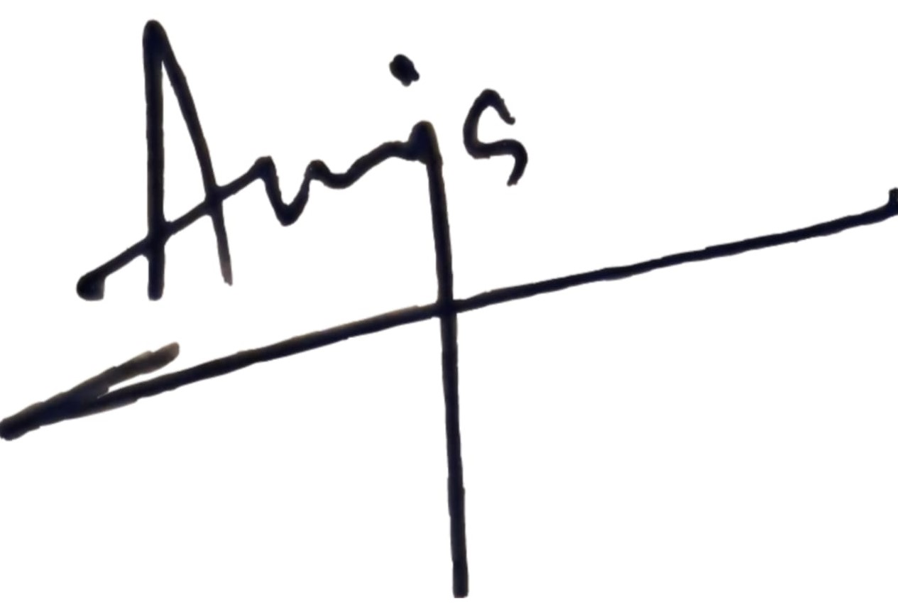

Authorized signatory
Name: Anuja Kishore
Designation: Chief Executive Officer
Place: Pune

SIGNED BY

Name:__________________________

Place:__________________________

